Health and Safety Engineering Handout
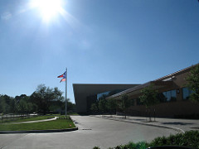
Keeping students safe!

Health and safety engineers develop procedures and design systems to prevent people
from getting sick or injured and keep property from being damaged. They combine their
knowledge of systems engineering and health and safety to make sure that chemicals, machinery, software, furniture and other products do not cause harm to people or damage property.

—U.S. Bureau of Labor Statistics

Your engineering challenge:
At middle and high schools across the country, students have been injured in labs and woodshop because they did not understand how to use tools and equipment safely.
Our principal has decided to seek outside help—yours!
Your job is to act as a safety engineer by making a list of rules and/or procedures that would keep the students at your school safe when they work in the lab.
To prepare for this task, please look carefully at the pictures of the lab in this packet.
Circle anything that you think might be unsafe, dangerous or potentially lead to injuries.

PICTURE 1
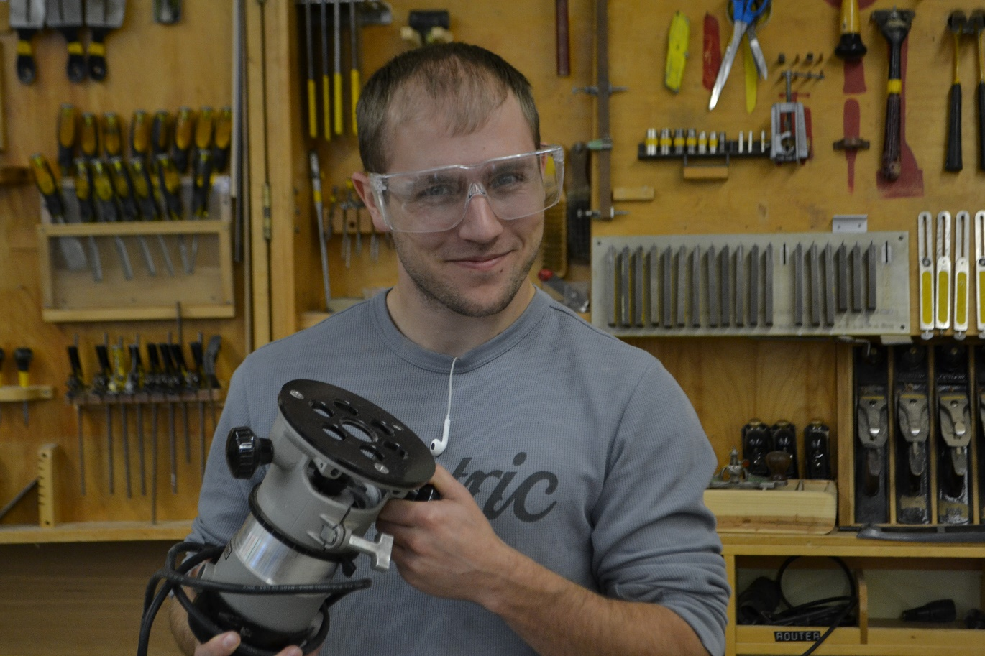
I don’t know how this works, but I can figure it out by myself.

PICTURE 2
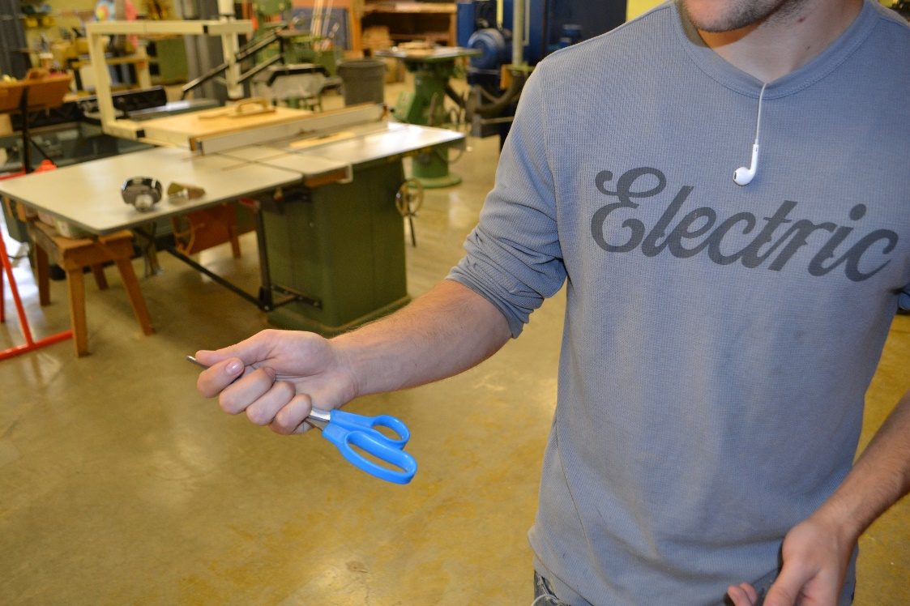

PICTURE 3
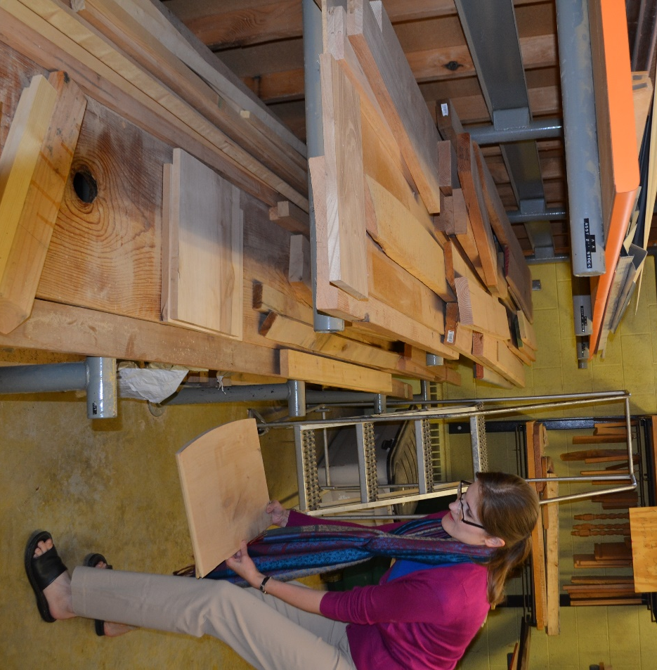

PICTURE 4
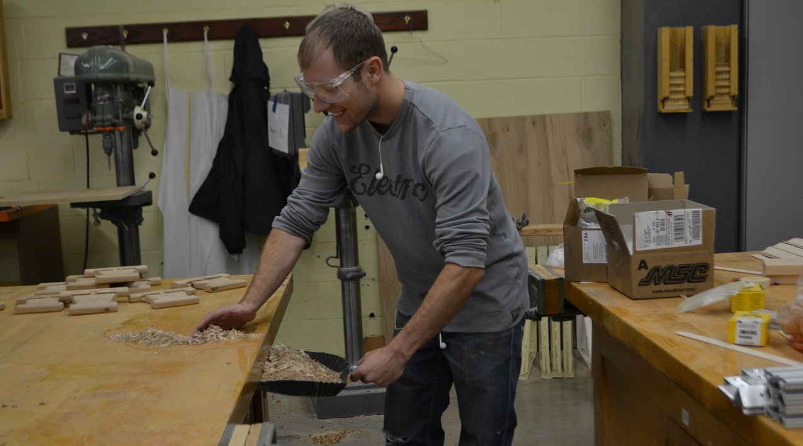

PICTURE 5
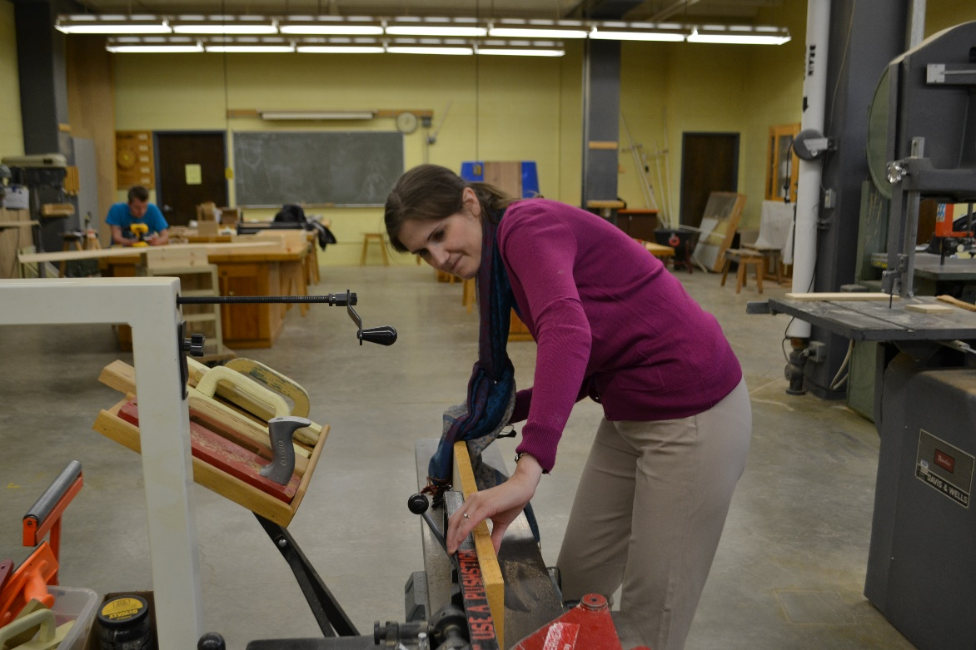

PICTURE 6
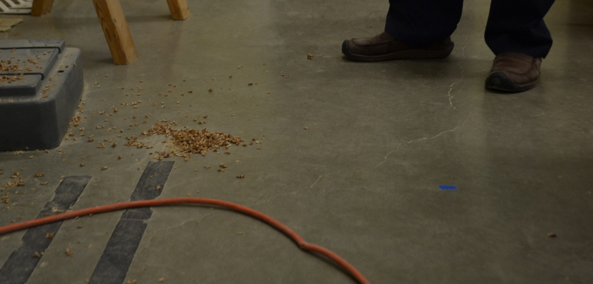

PICTURE 7
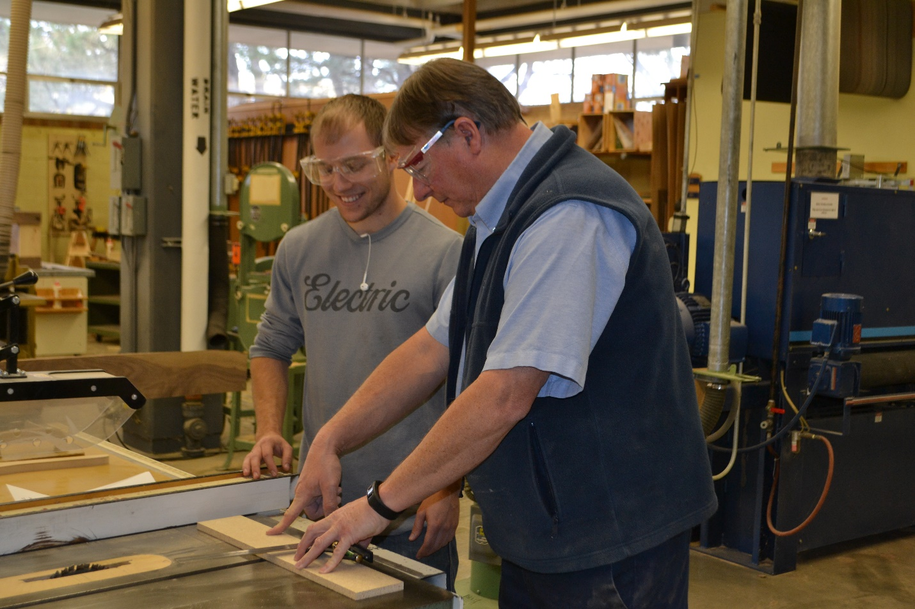
Let’s both stand here in the safety zone so we can get this work done more quickly.

My Recommendations as a Safety Engineer
After looking at these pictures, act as a safety engineer and list two different rules or procedures that students should follow in order to remain safe in the lab.
1.

2.

After you’ve written your two rules on this paper, write them on the poster and tape them up in the room.

Technology Lab Safety Rules
- Report all injuries, no matter how small, to your teacher as soon as possible.
- You must wear approved eye protection at all times in the shop area. At times, your teacher may also ask you to wear protective aprons, gloves or earplugs.
- Before entering the shop, secure loose clothing, remove loose jewelry, remove dangling cords (like those from headphones and hoodies), roll up long sleeves, and tie back long hair.
- Only one person is permitted stand inside the safety zone, or the areas around the machines, at one time.
- When you notice a damaged tool in the shop, report it to your teacher immediately.
- When using a sharp tool such as scissors, always hold the tool by the handle and point the sharp end away from your body, hands and eyes.
- Open-toed shoes may not be worn in the shop.
- Do not remove safety guards from machines.
- Only the machine operator is permitted to turn the machine on or off.
- Do not make unnecessary movements and noises in the lab because they could distract other students and cause accidents.
- Tools, machines, chemicals and other hazardous items may only be used when the teacher is present, you have received permission from the teacher, and you have received instruction in their specific safety precautions. Equipment may only be used for its intended purpose and may only be used for school projects approved by the teacher.
- Use a bench brush to clean debris and scraps from tables and machines.
- In case of an emergency, turn off the machine and follow your teachers’ instructions.
- You may need two or more people to safely handle or move large, long or heavy materials.
- To avoid spills, do not bring food and drinks into the lab.
- Keep your work area clean and tidy. Wipe up and dispose of sawdust, water, glue, paint and other spills correctly and as soon as possible. A clean work area helps to prevent tripping and slipping.
- Leave backpacks out of the lab by placing them in your regular classroom, preferably under a desk or table so they are not in the way where other people might trip over them.

Promoting Safety through Workplace Posters
The Occupational Safety and Health Administration (OSHA) is a federal organization designed to “assure safe and healthful working conditions for working men and women.” It passes standards designed to promote safety at the workplace, and it also provides training and outreach for workers on how to prevent injuries.
Your engineering challenge: Pretend that you are the head of OSHA and you have just received an annual report on the number of deaths that occurred at the workplace last year. The report includes the table below:
Bureau of Labor Statistics Reported Fatalities
2014 Construction Worker Fatalities | #
Caught in between | 39
Electrocutions | 74
Falls | 359
Oil and gas pipeline accidents | 21
Plumbing, heating and air conditioning accidents | 69
Power lines | 31
Struck by object | 73
- As the head of OSHA, interpret this chart. What are the most common hazards for American workers?

- As the head of OSHA, you want to develop a safety campaign to help American workers avoid these common hazards. With your team, design and create a workplace poster to hang in workplaces to remind people how to avoid this hazard. Make sure your workplace poster includes the following:
A) an image related to the hazard or the prevention of the workplace injuries that has been assigned to your group; and
B) a list of steps that people can take to avoid this injury while at the workplace.
Our team’s assigned hazard or injury type is ______________________________________________

