Modeling Bacteria Transformation Worksheet
DATA and OBSERVATIONS

[ Staple recombinant model here. ]

OVERVIEW of BACTERIA TRANSFORMATION
Instructions: Using the word choices provided in the boxes, fill in the numbered boxes with the steps of bacteria transformation and the lettered lines with the name of the structure next to it.

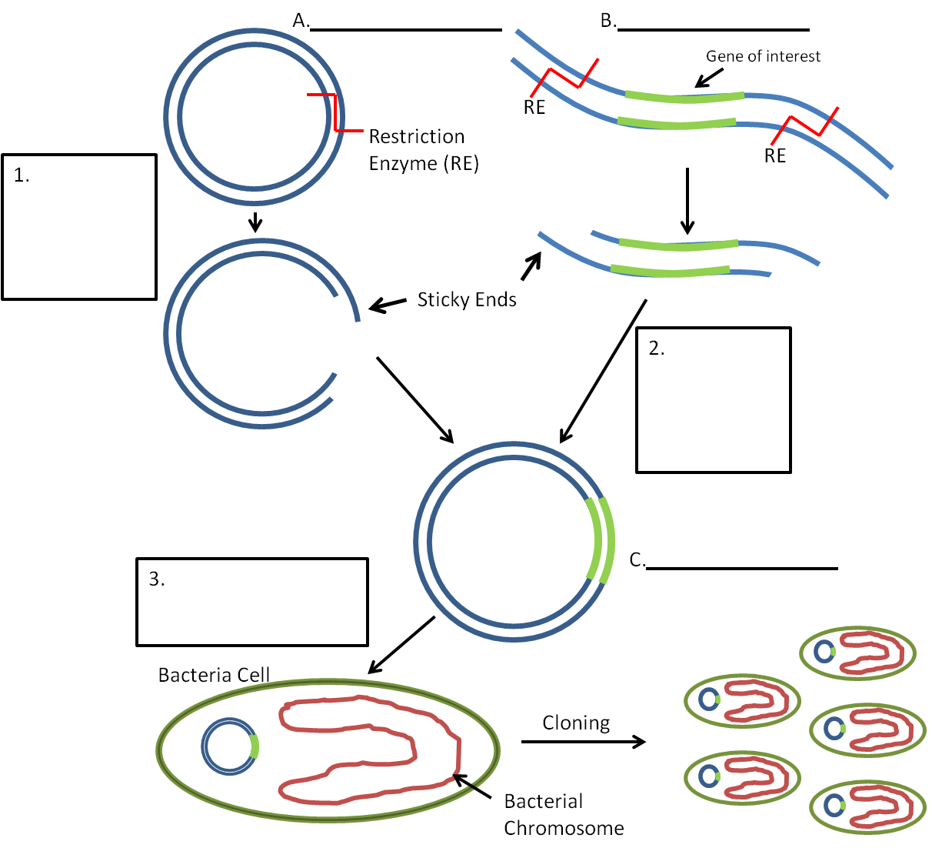

Word Choices for Letters
- foreign DNA with desired gene
- plasmid
- recombinant DNA
Word Choices for Numbers
- bacteria transformed with recombinant plasmid
- plasmid cut with restriction enzyme
- DNA ligase joins sticky ends to form recombinant plasmid

