Magnifier Iteration Checklist

Iteration | Material | Is it a Magnifier? | Observations: Draw or Write
Design 1 | Plastic Cup (Cut/not)  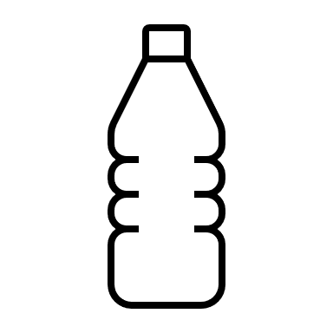 | Yes No
Design 2 | Plastic Bag  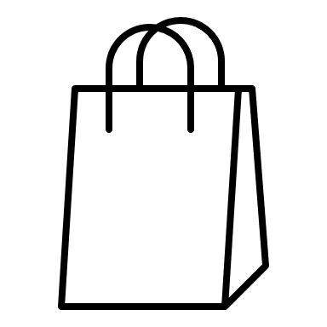 | 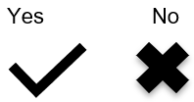
Design 3 | Saran Wrap  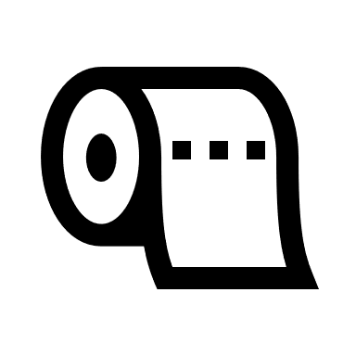
Design 4 | Plastic Cup (Cut/not)  + Water  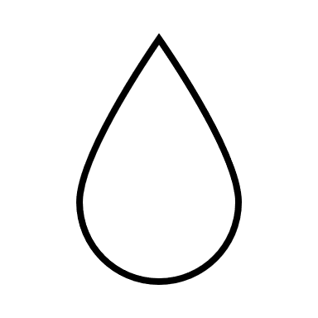
Design 5 | Plastic Bag + Water
Design 6 | Saran Wrap

Magnifier Iteration Extension Checklist

Iteration | Material:  Draw or Write | Is it a Magnifier? | Observations: Draw or Write
Design _____ |  | Yes No
Design _____
Design _____
Design _____
Design _____
Design _____

