Math Competition Test—6th Grade
- Annie’s macaroni and cheese recipe calls for two packages of cheddar cheese and one package of parmesan cheese. Joe’s macaroni and cheese recipe has three packages of cheddar and two packages of parmesan. Whose recipe has a higher ratio of packages of cheddar cheese to packages of parmesan cheese?
A. Both ratios are equivalent
B. Annie's recipe
C. Joe's recipe
D. neither
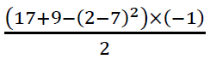
- Solve the following:
- 0.5
- -0.5
- 5.5
- 4.5
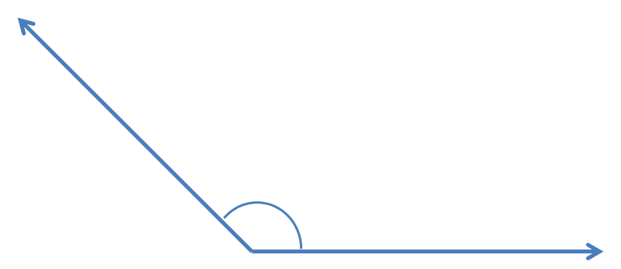
- The angle shown to the right can be described as:
A. Complementary
B. Acute
C. Right
D. Obtuse
- The ratio of females to males at a university is 8:5. If its student population includes 2,500 males, what’s the total student population?
A. 4,000 students B. 4,063 students C. 12,500 students D. 6,500 students
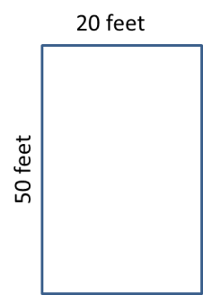
- A very hungry goat can eat 10 square feet of grass in three minutes. How long will it take the goat to eat all of the grass in the diagram to the right?
- 1,000 minutes
- 300 minutes
- 30 minutes
- 100 minutes
- What is the mean for the following number set?
13, 5, 22, 19, 7, 8, 14, 42
- 16.25
- 15
- 17.75
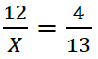
- 15.5
- Solve for X:
- 39
- 24
- 41
- none of the above

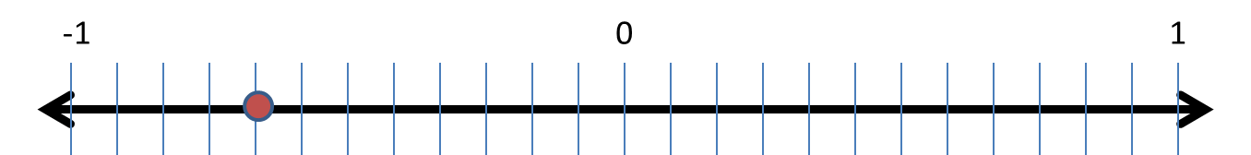
- What fraction is on the number line?
- -1/3
- 8/24
- -2/3
- -8/24
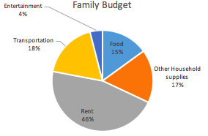
- This pie graph represents a family’s
annual budget. If the family’s total yearly
spending is $60,000, how much do they
spend on food?
- $10,000
- $13,200
- $9,000
- $4,800
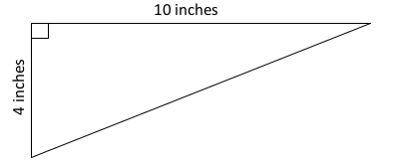
- Find the area of the triangle.
- 20 inches²
- 15 inches²
- 40 inches²
- 25 inches²

- Solve: 8.675 - 3.09 =
- 5.9
- 5.605
- 5.585
- 5.58
- What is the missing angle?
- 75°
- 55°
- 25°
- 65°
- Which expression is correct?

- A beaker and the liquid it contains together weigh 28.72 grams. The beaker weighs 2.3 grams. How much does the liquid alone weigh?
- 31.02 grams
- 31.2 grams
- 28.49 grams
- 26.42 grams

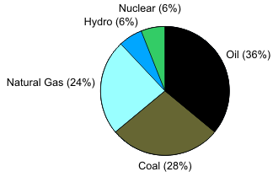
- This graph shows the energy consumption for Pawnee, IN.
If Pawnee consumed 66 trillion BTUs of energy,
how many BTUs are from nuclear power?
- 4 trillion BTUs
- 11 trillion BTUs
- 6 trillion BTUs
- 14 trillion BTUs
- What is 15/85 in lowest terms?
- 3/15
- 3/17
- 5/19
- 1/4
- 24 is 2/7 of which number?
- 44
- 84
- 168
- 68
- Solve: 14/28 ÷ 33/17 =
- 44/476
- 462/476
- 17/66
- 231/238
- From 200 meters above sea level; Joseph took off with a helicopter. Six hours later he landed the helicopter at 200 meters above sea level. Which integer represents Joseph’s change in altitude?
- 0
- 400
- 1,200
- 2,400
- Multiply 2.5 X 3.05 =
- 7.625
- 7.63
- 8.635
- none of these
- There are 2.54 centimeters in one inch. How many inches are in 12.7 centimeters?
- 4
- 5
- 6
- 7

- Fifteen students are 12-years-old and 10 students are 13-years-old. If you pick a student at random, what are the chances that the student will be 12-years-old?
- 40%
- 50%
- 60%
- 70%
- Last year, Josh and Nadia each donated money to charity. Josh donated $707.00 to help endangered animals, and Nadia donated $953.50 to save the rainforest. How much more money did Nadia donate than Josh?
- $23.50
- $165.50
- $246.50
- $1,660.50
- What fraction is shown on the number line?
- 3/1
- 3/10
- 4/10
- 3/100
- Solve: 8.821 - 5.23 =
- 3.691
- 2.591
- 3.599
- 3.591
- Taylor can swiftly fill up her cube-shaped fish tank at a rate of 0.5 cubic feet a minute. If she can fill her tank in 128 minutes, what is the length of the tank? (All sides of the tank have the same length.)
- 4 feet
- 6 feet
- 64 feet
- none of the above
- Of the 28 employees at the water slides, 21 are temporary employees. What percentage of the employees at the water slides are temporary?
- 70%
- 75%
- 21%
- 90%
- An area of a circle is 36π m². What is the circumference?
The equation for circumference is C = 2*r*π and area is A=r²*π
- 12 m
- 6π m
- 6 m
- 12π m

- Eight burgers cost $52. How much would five burgers cost?
- $30.50
- $31.50
- $32.50
- $33.50
- John ran six miles in one hour. Sarah can run 1½ miles in 15 minutes. Who is faster?
- John
- Sarah
- They are equal.
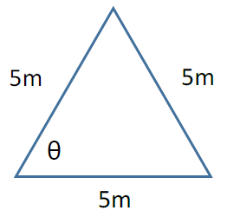
- Not enough information is provided.
- What is the angle of θ?
- 90°
- 45°
- 30°
- 60°
- You found a T-shirt that was on sale for $10, which is 25% off the original price.
How much did the T-shirt originally cost?
- $7.50
- $12.50
- $13.33
- none of the above
- Use the model to solve: 3/4 of 5/7 =
- 15/28
- 3/14
- 21/28
- 5/7
- Solve for X: X + 1 = Y – 3 12X = 4Y
- 3
- 5
- 4
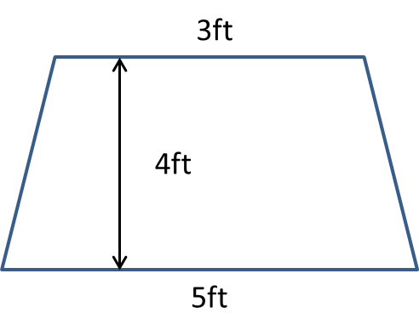
- 2
- What is the area of the trapezoid?
- 16 ft²
- 45 ft²
- 20 ft²
- 40 ft²
Tie Breaker
Estimate the number of dimes that would fit on this paper with no coins overlapping and no coins hanging off the paper. _________ dimes

