Math Competition Test—4th Grade
- Multiply 23 by 10,000:
A. 23,000 B. 230,000 C. 230,000 D. 2,300
- Jim has 12 turkeys, 3 chickens, and 2 cows. How many animals does he have that are not cows?
A. 3 B. 15 C. 14 D. 5
- Solve $4 \frac{1}{3}$ - $\frac{200}{6}`$
A. -29 B. $-28 \frac{1}{3}$ C. 29 D. $31 \frac{1}{3}$
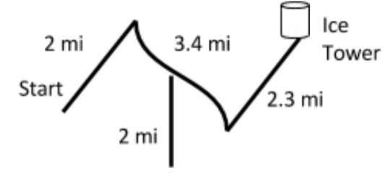
- Princess Anna needs to see Princess Elsa in her ice tower. To get there, she needs to use the path shown below. How many miles must she travel?
A. 9.7 miles
B. 7.7 miles
C. 11.1 miles
D. 4 miles
- Which number is a prime number?
A. 101 B. 25 C. 9 D. 33
- Emily sent a five-second-long snapchat to Rose who viewed it for three seconds. Then Rose sent a 10-second snapchat back to Emily who viewed it for six seconds. For how many seconds, in total, were the snapchats viewed?
A. 9 seconds B. 16 seconds C. 15 seconds D. 11 seconds
- Round 8.254 to the nearest hundredth.
A. 8 B. 8.3 C. 8.25 D. 8.26
- Convert 36 cups to quarts.
A. 8 quarts B. 9 quarts C. 10 quarts D. 11 quarts
- John can either see an old movie for $0.50, or a new movie for $7.50. John has 14 dollars. If he chooses to see a new movie, how many old movies can he still see?
A. 18 B. 28 C. 8 D. 13
- Subtract 501 – 132 =
A. 316 B. 370 C. 369 D. 319
- Solve 11.7 - 3.4 =
A. 9.3 B. 8.3 C. 8.1 D. 9.1

- Convert 15 quarts to cups.
A. 7.5 cups B. 60 cups C. 5 cups D. 3.75 cups
- Round 14.6 to the nearest whole number.
A. 10 B. 20 C. 14 D. 15
- If February 21 is Friday, what is the date of the following Friday?
A. February 14 B. February 28 C. March 1 D. February 27
- Reduce 20/80 to its lowest terms.
A. 10/40 B. 5/20 C. 10/80 D. 1/4
- On Twitter, tweets can be up to 140 characters long. If Elliot types 471 characters, what is the minimum number of tweets she publishes?
A. 2 B. 3 C. 4 D. 5
- Reduce 45/60 to its lowest terms.
A. 1/4 B. 3/4 C. 1/2 D. 1/1
- If March 15th is a Friday, what is the date of the following Thursday?
A. March 20th B. March 22nd C. March 21st D. March 23rd
- Reduce 30/60 to its lowest terms.
A. 15/30 B. 2 C. 1/2 D. 3/6
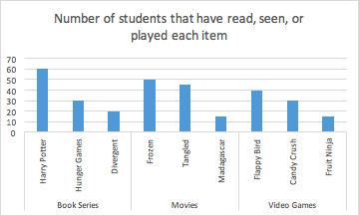
- How many students have read Hunger Games or played Candy Crush?
A. 50
B. 40
C. 70
D. 60

- Stephen lit a marshmallow on fire. He noticed that it burned for 1 minute and 12 seconds. Later, Stephen lit a toothpick on fire and noticed that it burned for 1 minute and 54 seconds. What is the total burn-time for both objects?
A. 3 minutes B. 2 minutes 6 secs C. 3 minutes 12 secs D. 3 minutes 6 secs
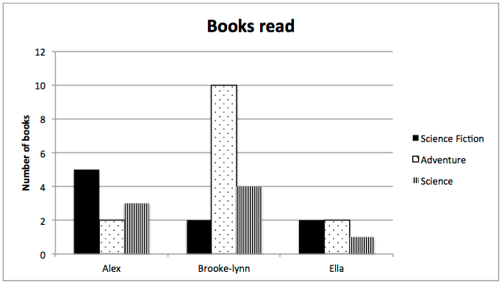
- Which student read the most books?
A. Alex
B. Brooke-lynn
C. Ella

- Solve 707 – 256 =
A. 441 B. 449 C. 451 D. 453
- What number is in the tenths place of 124.34?
A. 1 B. 2 C. 3 D. 4
- How many more students have seen Frozen compared to Madagascar?
A. 30 B. 35 C. 25 D. 15
- How many more students have seen movies than have played video games?
A. 25
B. 35
C. 40
D. 50

- If March 8th is a Saturday, what is the date of the following Thursday?
A. March 6th B. March 11th C. March 13th D. March 21st
- Which student seems to prefer science fiction?
A. Alex
B. Brooke-lynn
C. Ella

- Solve $5 \frac{7}{15} - 2 \frac{8}{15}$ =
A. $2 \frac{1}{15}$ B. $2\frac{14}{15}$ C. $3 \frac{14}{15}$ D. $3 \frac{1}{5}$
- Convert 144 inches to yards.
A. 1 B. 2 C. 3 D. 4
Tie Breaker
Estimate the number of dimes that would fit on this paper with no coins overlapping and no coins hanging off the paper. _________ dimes

