Build and Test a Conductivity Probe
Lab Handout
Introduction
When characterizing an unknown solution, it is helpful to know if the solution is conductive. In this lab activity, you will construct a simple conductivity probe and use it to determine whether some common household solutions conduct electricity.
Figure 1. A simple conductivity testing setup.
In the most basic sense, a conductivity probe provides an indication that charged particles are moving within a circuit. The probe may be designed to indicate conductivity through the illumination of a light, emission of sound or through measurement of an output value displayed on a monitor.
Figure 1 shows a simple conductivity probe setup.

Engineering Connection
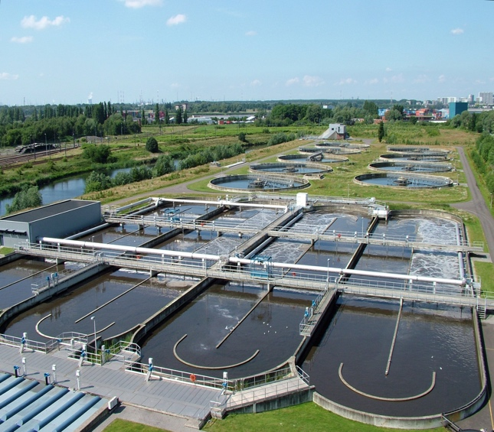
Conductivity probes are widely utilized in industry by engineers, often to gauge water quality. Consider the process of water treatment in which wastewater is purified and returned to the public water supply for reuse. Wastewater contains all kinds of dissolved solutes, many of which are electrolytes, meaning that the solutes break apart into ions when dissolved in water. Measuring the conductivity of a wastewater sample helps engineers to approximate the amount of dissolved ionic contaminants in the water; then, further conductivity measurements after the water has been treated can provide evidence that the contaminants have been removed.
A wastewater treatment facility in The Netherlands.
Image source: 2009 Annabel, Wikimedia Commons
https://commons.wikimedia.org/wiki/File:WWTP_Antwerpen-Zuid.jpg
Wastewater treatment monitoring is just one of many applications in which conductivity probes are used when water quality measurements are imperative to ensuring the health of a population or an industrial process.
In this lab activity, you will construct a simple resistive conductivity probe that you will use as a tool to measure the relative conductivity of four different aqueous solutions.

P
DISCUSSION • LEARNING OBJECTIVES
PREPARING

- Read the background and engineering connection sections on the previous page.
How do you think conductivity measurements will differ in samples of untreated and treated wastewater? Why?

- Electrical current requires the movement of charged particles. Considering this, what types of solutes, when dissolved in water, would result in a solution that conducts electricity?

- Figure 1 (on the previous page) shows a ready-made conductivity sensor with two probes immersed into a solution. What types of materials should the probes be made of? Explain why.

- Based upon the reading that you have done on conductivity, which of the following solutions will conduct electricity? Write a brief justification for the solutions you choose.

Sugar water
Salt water
Distilled water
Tap water

E
Probe Construction • Testing •Connecting to Arduino
EXPERIMENTING

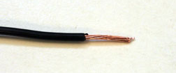
Part 1: Constructing the Probe
Obtain the following materials:
- 2 x 20 cm lengths of solid 22 gauge insulated copper wire
- 2 x 10 cm lengths of 32 gauge nichrome wire
A stripped wire.
- wire stripper
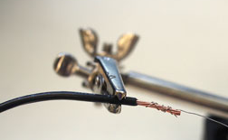
- plastic barrel from an ink pen
- electrical tape

Steps
- Use a wire stripper to remove approximately 1 cm of insulation from the ends of each of the two insulated wires.
A wrapped wire.
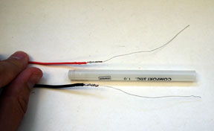
- Solder the nichrome wire to the insulated wire. For best results, twist the two wires together before soldering. Repeat for the second wire.

- Tape the two wires you just soldered on opposite sides of the pen barrel.

- As you tape them, leave a 1 mm section of the nichrome wires exposed near the end of the barrel, so that the probe can make physical contact with the solution.
Placing the wires before taping.

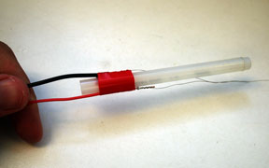
- Use electrical tape to cover the rest of the nichrome wire, with the exception of the 1 mm gap.

- Congratulations! You have constructed a conductivity probe!

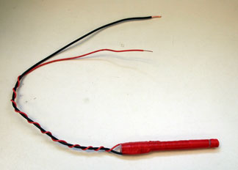
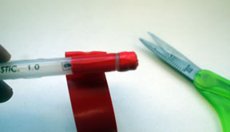
The completed sensor.
Leaving a 1 mm gap in the tape.
Wires taped to the pen barrel.
Part 2: Testing the Probe
Now that you have made your probe, let’s see how it responds to solutions of known conductivity.
Obtain the following materials:
- 4 plastic cups
- table salt
- sugar
- distilled water
- tap water
- prototyping breadboard
- jumper wire(s)
- 470 Ω resistor (yellow-purple-black)
- LED
- 9V battery with wire connectors

Steps
- Using a breadboard and the electrical components in the diagram, create the circuit in Figure 2. Note the connecting points where the conductivity probe will be connected into the circuit.

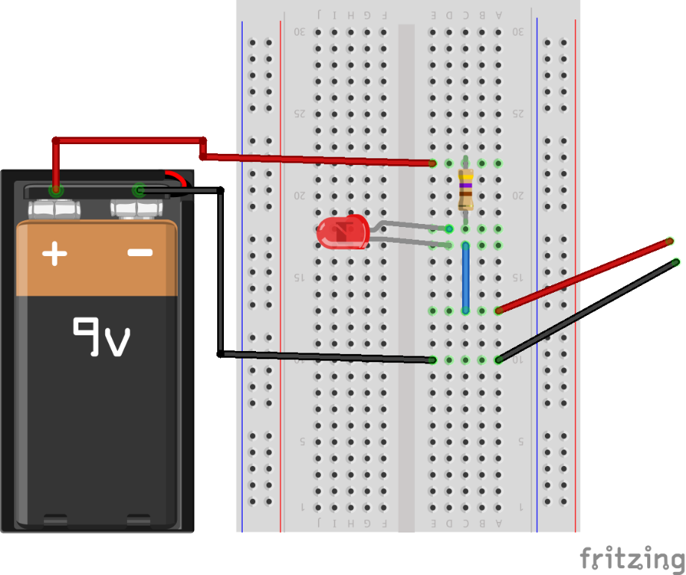
Figure 1. Conductivity sensor testing setup.
conductivity probe

- Have your teacher check your breadboard before continuing to step 3.

- Fill three cups approximately halfway with distilled water.
- Label the three cups as sugar water, salt water and distilled water.
- Using a spatula or spoon, add a spoonful of sugar into the sugar water cup. Stir the solution until all the sugar has dissolved.
- Add a spoonful of table salt into the salt water cup. Stir the solution until all the salt has dissolved.
- Fill a fourth cup halfway with tap water and label it “tap water.”
- Test your conductivity probe by immersing the tip of the probe into the sugar water solution. Record your observations in Data Table 1.
- Rinse the probe with distilled water and dry to avoid any contamination among the solutions.
- Repeat steps 8 and 9 with the salt water, tap water and distilled water.
- Save your solutions for use in Part 3.
Data Table 1
Solution | LED Glow? | Observations
Sugar water

Salt water

Distilled water

Tap water

Part 3: Connecting the Probe to the Arduino
Now that you have constructed your probe and tested its function, it is time to connect it to an Arduino so that you can quantify the relative conductivity of solutions. In this part of the lab, you will use an Arduino, LCD display and your probe to make a sensor with a numerical output that is displayed via the LCD display. As the conductivity of the solution increases, the relative conductivity displayed on the LCD screen will increase.
Obtain the following materials:
- Arduino Uno
- prototyping breadboard
- 16-character x 2-line LCD display
- variable potentiometer (trimpot)
- 10K Ω resistor (brown-black-orange)
- 220 Ω resistor (red-red-brown)
- connecting wires
- conductivity sensor from Part 2
- solutions from Part 2
Steps
- Begin by constructing the circuit shown in Figure 3, paying careful attention to the diagram.

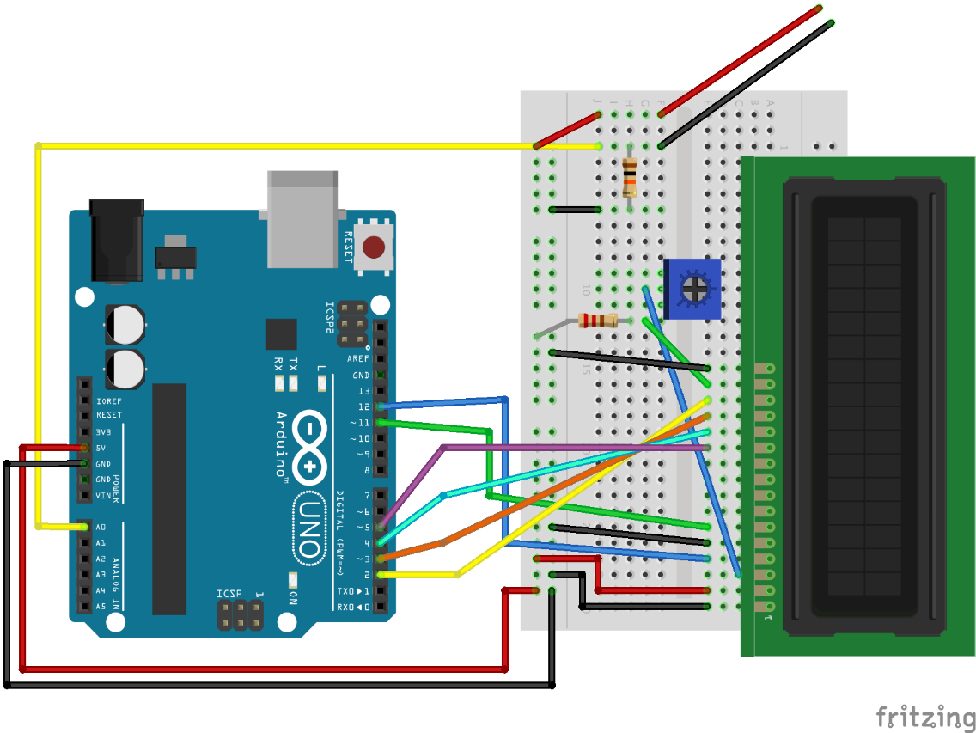
Figure 3. Circuitry for connecting the probe to the Arduino UNO.
conductivity probe

- Have your teacher check your circuit before proceeding to the next step.

- Open the Arduino software and enter the following code:
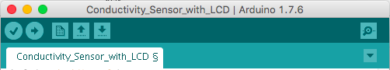
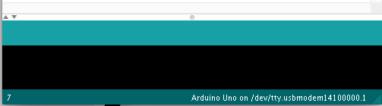
#include <LiquidCrystal.h>
LiquidCrystal lcd(12,11,5,4,3,2);

const int switchPin = 6;
int switchState = 0;
int condVal;

void setup() {
Serial.begin(9600);
lcd.begin(16,2);
pinMode(switchPin, INPUT);

}

void loop() {
condVal = analogRead(A0);
float voltage = condVal*(5.0/1023.0);
lcd.setCursor(0,0);
lcd.print("Rel Conductance");
lcd.setCursor(0,1);
lcd.print(voltage);
delay(50);
}
Figure 4. Conductivity measurement code for Arduino.

- Verify the code, and then use a USB cord to connect your Arduino to the computer.
- Upload the verified code.
- Congratulations! Your sensor is ready to test!
To verify that your probe is working correctly connected to the Arduino, test the setup by immersing the probe into the same four solutions that you used in Part 2. Follow this basic procedure:
- Immerse the probe into the sugar water solution and observe what happens.
- In Data Table 2, record the relative conductivity displayed on the LCD screen, as well as any other observations.
- Rinse the probe with distilled water and dry to avoid any contamination.
- Repeat steps 7 through 9 for the remaining three solutions.
Data Table 2
Solution | Rel Conductivity | Observations
Sugar water

Salt water

Tap water

Distilled water

- Discard the testing solutions as directed by the teacher. Clean up your lab space, and begin work on the analyzing reading and questions on the next page.

CT

Design your own experiment

CRITICAL THINKING

Part 4: It’s Your Turn!
Before beginning this concluding experiment, research how engineers use conductivity probes. Wastewater treatment monitoring is one of myriad real-world ways that engineers use conductivity probes.
Develop an experiment based upon your experience completing Parts 1-3.
- Imagine: How might you use your probe to tell you something about the world around you?
In what situations would it be useful to know the conductivity of something?
- Have your teacher read your proposal—and then try it!
- Record your procedure and results in the space below.
You may find the following resource on the Theory and Application of Conductivity helpful as you plan your experiment: http://www2.emersonprocess.com/siteadmincenter/PM%20Rosemount%20Analytical%20Documents/Liq_ADS_43-018.pdf

A
READING • QUESTIONS

ANALYZING

Reading
- Read the following online article on electrolytes and nonelectrolytes, including a six-minute video:
http://www.ck12.org/chemistry/Electrolytes-and-Nonelecrolytes/lesson/Electrolytes-and-lectrolytes/?referrer=concept_details
- Check your understanding of the reading by completing the digital experiment at this website:
http://www.ck12.org/assessment/tools/geometry-tool/plix.html?eId=SCI.CHE.432.4&questionId=53ceca67da2cfe48ba6cfc9a&artifactID=1817915&backUrl=http%3A//www.ck12.org/chemistry/Electrolytes-and-Nonelecrolytes/%23interactive
- Then answer the questions below.
Questions
- How did the predictions you made in the preparing section compare to your observations?
What results surprised you?

- Did you find a measureable difference between distilled water and tap water?
If so, explain. If not, why not?

- What are the benefits of using the conductivity probe with the Arduino, compared to using the probe with a LED and battery, as you did in Part 2?

