Molecular Modeling Worksheet
- Draw a molecule of ethane on your paper. Then use ChemDraw to draw it in your computer.

- Write the chemical formula for ethane.

- What is its molecular weight?

- What is its elemental analysis?

- Draw a molecule of ethanol on your paper. Then use ChemDraw to draw it in your computer.

- Write the chemical formula for ethanol.

- What is its molecular weight?

- What is its elemental analysis?

- Describe a Newman projection. Use ChemDraw to draw it in your computer.
What is the purpose of Newman projections?

- What is the difference between staggered and eclipsed? (Please draw in ChemDraw.)

- Draw the Newman projection of ethanol in the staggered conformation.

- Draw the Newman projection of ethanol in the eclipsed conformation.

- In the energy diagram below, how does energy relate to staggered and eclipsed? Please explain.
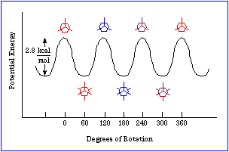

- Next to each number below, label the pictured conformations as staggered or eclipsed.

 
 
 
 
 
 

