Angular Velocity Experiment Worksheet Answer Key
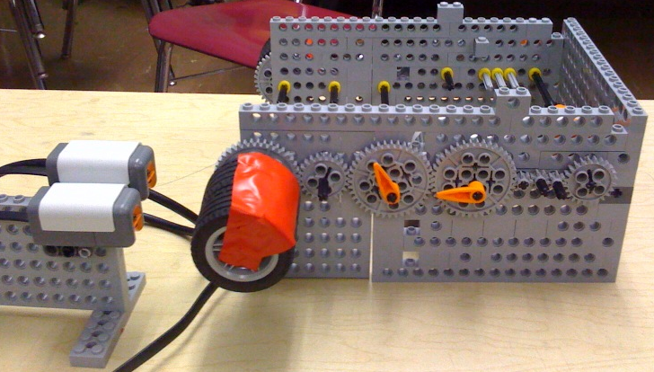

Figure 1. Example data logging experimental setup.

Vocabulary/Definitions
Word | Definition
data logging | Using a computer to collect and record data over an extended period of time through the use of a sensor.
length | The measure of how long something is from one end to another.
period | The length of time to complete one cycle.
gear | A rotating machine with cut teeth.
gear train | A set of gears that is able to transfer rotational motion.
circumference | The distance around a circle.
degree | The unit of measure for a given angle.
radian | The unit of measure for a given angle equal to 57.296 degrees. The measure of a circle is equal to 2π radians = 360°.
velocity | The distance traveled per unit time.
angular velocity | The change in rotation traveled per unit time.
optimal | Best suited for the situation. The best choice, arrangement, result or decision obtainable that meets specific requirements.

Hypothesis
Expect students’ hypotheses to support the idea that different gear trains with different ratios will affect the angular velocity of the wheel. More in-depth hypotheses may remark that gear trains with a large gear attached to the motor and a small gear attached to the wheel will result in a greater angular velocity of the wheel, when compared to a gear train with the gears in vise-versa order or gears that are of the same size.

Materials
- LEGO MINDSTORMS Education NXT base set
- 2 LEGO MINDSTORMS NXT intelligent bricks
- calculator
- ruler
- 2 pieces electrical tape (not black)
To share with the entire class:
- computer with LEGO MINDSTORMS Education NXT Software 2.1
(programming and data logging)

Procedure

Explain and/or sketch your data logging experimental setup.
List the steps you followed to construct the device.
Students construct the device that operates like the example in the photograph on the first page of this worksheet.
Here, under Procedure, look to see if students wrote a brief but accurate explanation and/or drawing of what they built, as well as all the steps they followed to construct the device.

Data

Calculate the angular velocity with the three physics-based equations:
circumference = 2*π *(radius) (Equation 1)
degrees = radians * (180/π) (Equation 2)
angular velocity = degrees/ (time for one period) (Equation 3)
Answer: For the table below, expect answers to vary since different motors and the gear train friction cause differences between groups. The gear ratio for the “big” 40-tooth gear is at a 1:1 ratio, thus the output axle will spin at the same speed as the axle coming from the motor. The example took the time (period) of 3 full rotations and determined the angular velocity. Note the gear ratios of medium:medium and small:small will have the same angular velocity as the big:big, since they all have the same gear ration of 1:1.
Gear Length | Circumference  (radians) | Rotations  (degrees) | Period  (seconds) | Angular Velocity  (degrees/second)
big:big  example | $$6π$$ | $$360*3$$  $$=1080$$ | 4.5 sec. | $$\frac{1080}{4.5}=240\frac{deg}{sec}$$
medium:medium |  |  |  | Same as the value for big:big
small:small |  |  |  | Same as the value for big:big
big:medium |  |  |  | Should be between a value between big:big and big:small  (second-largest value)
big:small |  |  |  | Should be the largest value for the 2 gear system
small:medium |  |  |  | This should be the smallest value

Now, let’s look at length and gear ratio:
Expect the first three (4 big, 4 medium and 4 small) to have values similar to the big:big, medium:medium and small:small, since they all have gear ratios of 1:1. Do not be surprised if the values are a little lower when compared to the two-gear system, as the additional gears add friction, causing lower angular velocities. The same ideas apply for the rest of the gear ratios; expect them to be similar to the two-gear setup, except a little slower due to friction.
Gear Length | Circumference  (radians) | Rotations  (degrees) | Period  (seconds) | Angular Velocity  (Degrees/ seconds)
4 big
4 medium
4 small
1 big:3 medium
3 big:1 medium
3 big:1 small
1 big:3 small
3 small:1 medium
1 small:3 medium

Results

What does your data tell you about gears and angular velocity?
Expect students to observe and explain that the different gear ratios changed the angular velocity. Expect the gear train with the largest gear attached to the motor and the smallest gear to the wheel to have the largest angular velocity; expect students to have both measured/hard and observational data that show this.

Conclusions

Do your experimental results agree with your hypothesis? Why or why not?
The gear ratio with the big:small ratio had the highest angular velocity, with the big:medium being the next gear train with the highest angular velocity. The next gear train with the highest angular velocity was the big:big, which had the same angular velocity as medium:medium. The gear train that had the smallest angular velocity was the small:medium. The gear trains that used more than two gears produced slightly smaller angular velocity, compared to the two-gear system, which used the same set of gears.

Optimal Solution

What gear train is optimal for a high angular velocity?
A gear train with the highest ratio of the number of input teeth to output teeth has the largest gear ratio and is optimal for the highest angular velocity.

