Solar Farm Cost-Benefit Analysis Worksheet
Solar panels use energy from the sun to create electricity. The systems are called photovoltaic panels because they use semiconducting materials to convert photons (light) into electricity. Solar panels are considered dispatchable energy generators, which are electricity sources that can be turned on and off when needed. These forms of energy are easily inserted into the power grid as needed. Other forms of dispatchable energy include wind and natural gas. While not relied on for extended periods of time, they have the benefit of being able to produce electricity on short notice to supplement traditional means of electricity production.
One challenge to solar panel farms is the amount of land required. In this engineering analysis exercise, we will conduct a cost-benefit analysis for different solar farm scenarios that takes into consideration any ecosystem disruption impacts.
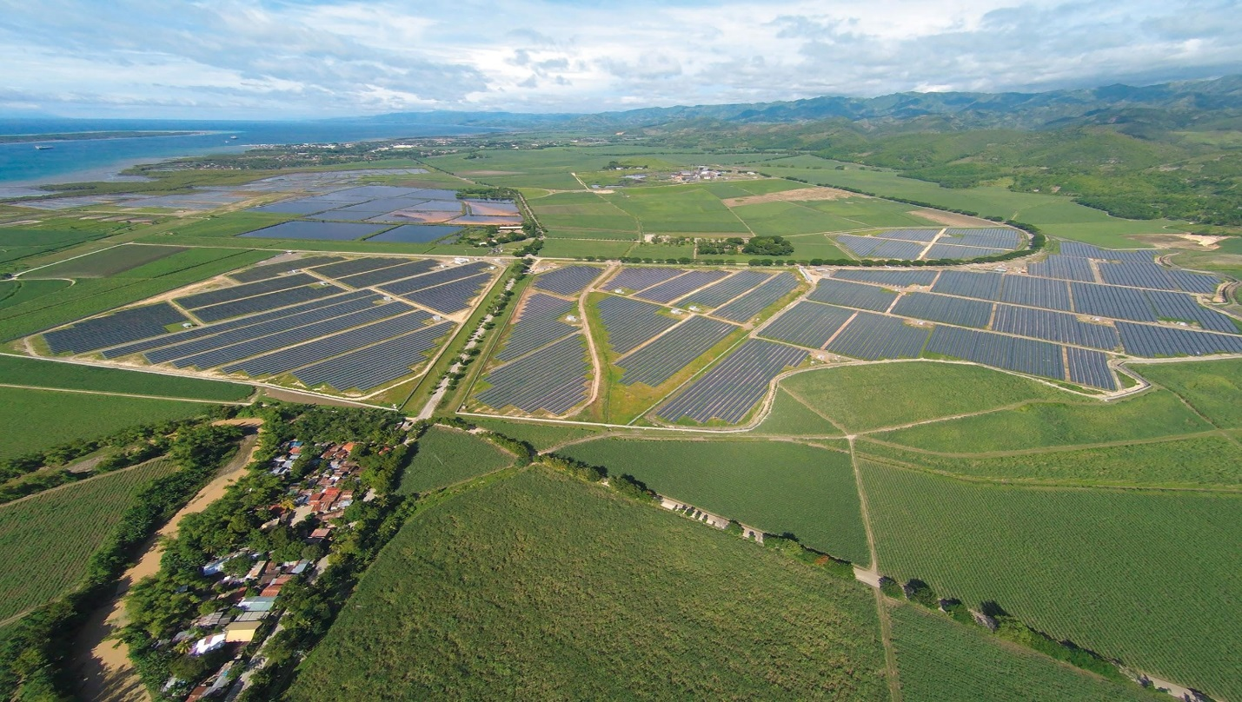

A solar farm in the Philippines. Photo source: 2015 Kanadaurlauber, Wikimedia Commons CC BY-SA 4.0
https://commons.wikimedia.org/wiki/File:San-Carlos-Solar-Energy-I-SaCaSol-I_Full-Area_1.jpg
Your engineering task: To design your own solar panel farm that meets the following constraints:
- You have at most 100 available plots to fill with solar panels (see grid below).
- Currently each plot is home to a family of sheep that supplies the local wool industry, which requires a $200 compensation to the rancher for each plot removed from raising sheep.
- You have at most $15,000 to spend.
- You must generate at least 400 watts of energy per day using any mix of two types of solar panels:
- The basic model costs $100 each and generates 7 watts of energy per day while occupying one plot, but it eliminates all plant growth due to the shade it creates, which displaces the sheep.
- The deluxe model costs $450 each and generates 13 watts of energy per day while occupying two plots, but it is elevated so that plants can survive under it, which means the sheep can remain.

On the grid below, mark with a “B” the plots that contain the basic model, a “D” those containing the deluxe model, and “X” those that remain undisturbed. Explain your reasoning and demonstrate your calculations of cost and energy produced.
Grid of available plots for solar panels:
Analysis Questions
1. What are some other impacts that solar farms might have on ecosystems?

2. Brainstorm some potential design solutions to decrease the reliance on open land for solar panels.

3. Why are dispatchable energy sources beneficial as components of the electrical grid system?

4. Consider your final product, which is a solar farm design. If you were real-world engineers, how would you go about conducting a comprehensive cost-benefit analysis for your final design? What specific information would you need?

