Lewis Dot Structures and Molecule Geometries Worksheet
Answer Key
How to Draw a Lewis Dot Structure
- Find the total sum of valence electrons that each atom contributes to the molecule or polyatomic ion.
- You can quickly refer to the periodic table for the group A number for this information.
- In the case of polyatomic anions, add the electrons represented by the negative charge to the total number of valence electrons.
- In the case of polyatomic cations, subtract electrons represented by the positive charge from the total number of valence electrons.
- Drawing the molecule.
- Look up the electronegativity values for each element in your structure. The least electronegative atom represents the central atom. Hydrogen is the only exception to this since it forms only one bond.
- Arrange the remaining atoms symmetrically around the central atom.
- Apply the octet rule for all atoms except for hydrogen, which obeys a “duet” rule.
- Each single bond represents two electrons.
- Beginning with the surrounding atoms, place the remaining electrons around each atom until its octet is achieved with the exception of hydrogen, which requires only two electrons.
- If not enough electrons exist to meet the octet rule using single bonds, then double or triple bonds between two atoms are required. If short by two electrons, try a double bond, and if short by four electrons, try a triple bond or two double bonds.
###
1. CH₄
Total number of  valence electrons: 8 | CAD engineered 3D sketch model  (show dipole arrows)
Lewis structure:

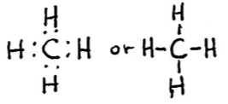

Is there a polar bond in this molecule?  yes or no | VSEPR shape name: tetrahedral  Bond angles: 109.5 degrees  Overall molecular polarity: polar or nonpolar

2. CO₂
Total number of  valence electrons: 16 | CAD engineered 3D sketch model  (show dipole arrows)
Lewis structure:

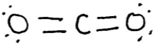

Is there a polar bond in this molecule?  yes or no | VSEPR shape name: linear  Bond angles: 180 degrees  Overall molecular polarity: polar or nonpolar

3. NH₃
Total number of  valence electrons: 8 | CAD engineered 3D sketch model  (show dipole arrows)
Lewis structure:

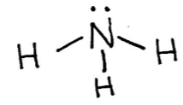

Is there a polar bond in this molecule?  yes or no | VSEPR shape name: trigonal pyramidal  Bond angles: 109.5 degrees  Overall molecular polarity: polar or nonpolar

4. H₂O
Total number of  valence electrons: 8 | CAD engineered 3D sketch model  (show dipole arrows)
Lewis structure:

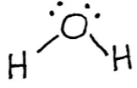

Is there a polar bond in this molecule?  yes or no | VSEPR shape name: bent  Bond angles: 120 degrees  Overall molecular polarity: polar or nonpolar

5. N₂
Total number of  valence electrons: 10 | CAD engineered 3D sketch model  (show dipole arrows)
Lewis structure:

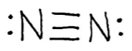

Is there a polar bond in this molecule?  yes or no | VSEPR shape name: linear  Bond angles: 180 degrees  Overall molecular polarity: polar or nonpolar

6. SO₂
Total number of  valence electrons: 18 | CAD engineered 3D sketch model  (show dipole arrows)
Lewis structure:

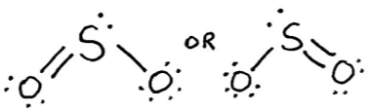

Is there a polar bond in this molecule?  yes or no | VSEPR shape name: bent  Bond angles: 120 degrees  Overall molecular polarity: polar or nonpolar

7. O₂
Total number of  valence electrons: 12 | CAD engineered 3D sketch model  (show dipole arrows)
Lewis structure:

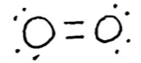

Is there a polar bond in this molecule?  yes or no | VSEPR shape name: linear  Bond angles: 180 degrees  Overall molecular polarity: polar or nonpolar

8. O₃ – use yellow ball for central atom
Total number of  valence electrons: 18 | CAD engineered 3D sketch model  (show dipole arrows)
Lewis structure:

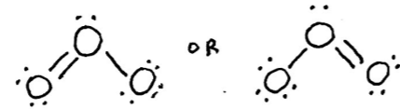

Is there a polar bond in this molecule?  yes or no | VSEPR shape name: bent  Bond angles: 120 degrees  Overall molecular polarity: polar or nonpolar

9. CO
Total number of  valence electrons: 10 | CAD engineered 3D sketch model  (show dipole arrows)
Lewis structure:

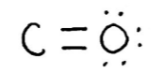

Is there a polar bond in this molecule?  yes or no | VSEPR shape name: linear  Bond angles: 180 degrees  Overall molecular polarity: polar or nonpolar

10. CO₃²⁻
Total number of  valence electrons: 24 | CAD engineered 3D sketch model  (show dipole arrows)
Lewis structure:
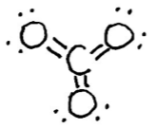

Is there a polar bond in this molecule?  yes or no | VSEPR shape name: trigonal planar  Bond angles: 120 degrees  Overall molecular polarity: polar or nonpolar

11. NO₃¹⁻
Total number of  valence electrons: 24 | CAD engineered 3D sketch model  (show dipole arrows)
Lewis structure:

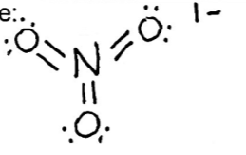

Is there a polar bond in this molecule?  yes or no | VSEPR shape name: trigonal planar  Bond angles: 120 degrees  Overall molecular polarity: polar or nonpolar

12. CF₂Cl₂ (CFC = chlorofluorocarbon)
Total number of  valence electrons: 32 | CAD engineered 3D sketch model  (show dipole arrows)
Lewis structure:

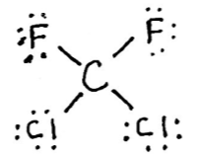

Is there a polar bond in this molecule?  yes or no | VSEPR shape name: tetrahedral  Bond angles: 109.5 degrees  Overall molecular polarity: polar or nonpolar

