Visual Aid
Bonding electron pairs | Lone pairs | Electron domains (steric #) | Shape | Ideal bond angle  (bond angle of example) | Example | Image
2 | 0 | 2 | linear | 180° | CO₂
3 | 0 | 3 | trigonal planar | 120° | BF₃ | 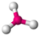
2 | 1 | 3 | bent | 120° (119°) | SO₂ | 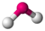
4 | 0 | 4 | tetrahedral | 109.5° | CH₄ | 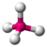
3 | 1 | 4 | trigonal pyramidal | 109.5 (107.8°) | NH₃ | 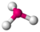
2 | 2 | 4 | bent | 109.5° (104.48°)^{[10][11]} | H₂O
5 | 0 | 5 | trigonal bipyramidal | 90°, 120°, 180° | PCl₅ | 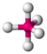
4 | 1 | 5 | seesaw | ax–ax 180° (173.1°),  eq–eq 120° (101.6°),  ax–eq 90° | SF₄
3 | 2 | 5 | T-shaped | 90° (87.5°), 180° (175°) | ClF₃ | 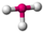
2 | 3 | 5 | linear | 180° | XeF₂
6 | 0 | 6 | octahedral | 90°, 180° | SF₆ | 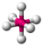
5 | 1 | 6 | square pyramidal | 90° (84.8°) | BrF₅ | 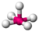
4 | 2 | 6 | square planar | 90°, 180° | XeF₄ | 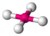
7 | 0 | 7 | pentagonal bipyramidal | 90°, 72°, 180° | IF₇ | 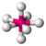
6 | 1 | 7 | pentagonal pyramidal | 72°, 90°, 144° | XeOF₅⁻ | 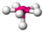
5 | 2 | 7 | planar pentagonal | 72°, 144° | XeF₅⁻
8 | 0 | 8 | square antiprismatic |  | XeF₈²⁻
9 | 0 | 9 | tricapped trigonal prismatic |  | ReH₉²⁻ | 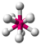
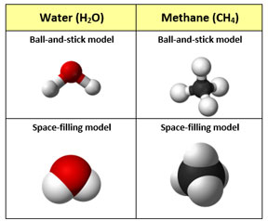

Figure 1. Ball-and-stick (top) versus space-filling models (bottom) for water and methane.

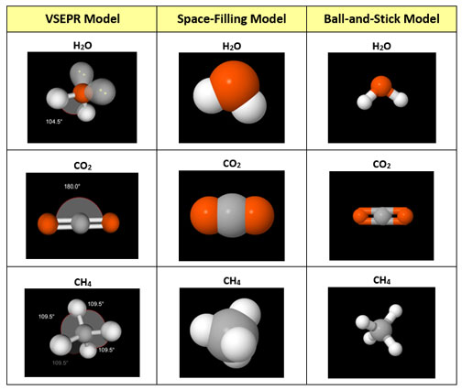

Figure 2. An example reference chart for the comparison of three types of molecular models.

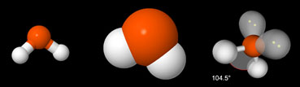

Three ways to model the geometry of a molecule of water (H2O).

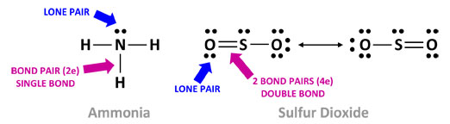

Figure 3. Chemical engineers know that the location(s) of lone pair electrons
determines the overall molecular geometry.

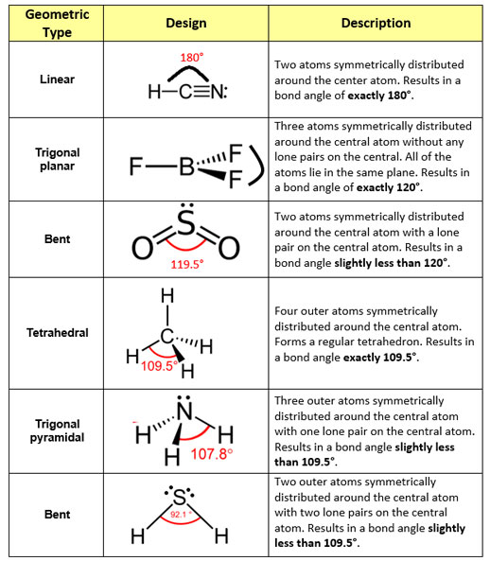

Table 1. A reference for determining the molecular geometry.

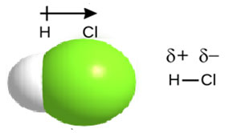

Figure 4. Because the bonded electrons are pulled closer to Cl due to its greater electronegativity, the HCl molecule contains a polar covalent bond.

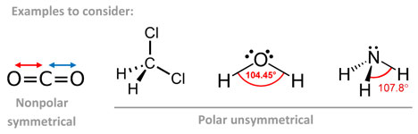

Figure 5. Chemical engineers use bond types and bond type symmetry to determine molecular polarity. If bond types symmetrically cancel each other out, then the molecular geometry is nonpolar. If the bond types do not cancel each other out, then the molecular geometry is polar.

