**Viscosity Worksheet**

1. **List two methods that engineers use to measure viscosity.**
2. **The table below includes laboratory observations of four different fluids. Fill in the third column of the table with one of the following choices for type of fluid:**

TeachEngineering.org – Free STEM Curriculum for K-12

* 1. **Shear Thickening Fluid**
  2. **Shear Thinning Fluid**
  3. **Newtonian**
  4. **Bingham Plastic**

|  |  |  |
| --- | --- | --- |
| *Tested Fluid* | *Laboratory Observations* | *Type of Fluid* |
| Fluid A | Experienced an increase in viscosity as its velocity (rate of shear) increased. |  |
| Fluid B | Behaves as a solid at low stresses, but flows like a fluid at high stresses. |  |
| Fluid C | Maintains constant viscosity that is independent of velocity (rate of shear). |  |
| Fluid D | Experiences a decrease in viscosity as its velocity (rate of shear) increases. |  |

1. **For shear thickening and shear thinning, complete the following:**
   1. **Provide a description of the molecular interactions that results in this type of fluid (i.e. What is the molecular-level structure?).**
   2. **Provide one example of how this fluid type is used in engineering and why it’s viscous properties are particular useful for the design (i.e. why is the molecular-level structure you described in part a important in the functioning of this design?).**
2. **Describe how the following two equations are similar:**

 

1. **Label on the following graph which response is due to a fluid that has Newtonian, shear thinning, shear thickening and Bingham plastic behavior.**

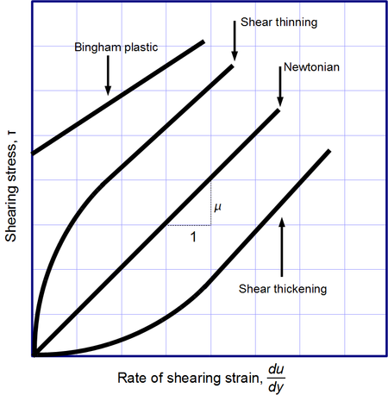

1. **Research online examples of fluids that are shear thinning and shear thickening. Give an example of each type of fluid (shear thinning and shear thickening) and describe how engineers have used the properties of that fluid to their advantage.**