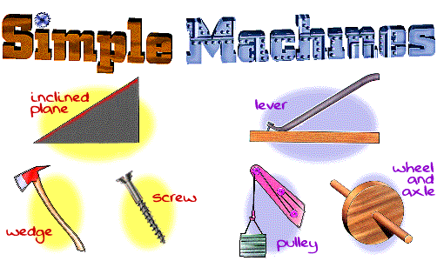

|  |  |
| --- | --- |
| **Simple Machine Type** | **Mechanical Advantage** |
| Wedge | To drive objects apart |
| Wheel and axle | To reduce the friction of moving something |
| Lever | To increase or decrease the applied force |
| Inclined plane | To move objects to a greater height |
| Screw | To hold things together or to lift an object |
| Pulley | To change the direction of a force |

A **mechanical advantage** is using simple machines so that the task is easier.

