**Angles and Reflections Worksheet**

**Part 1:** Use a protractor to draw lines and measure each of the angles below to the nearest degree. Write the angle measurements (in degrees) in the blank spaces provided.

Angles that are less than 90 degrees (<90°) are called: ____________________________

**(1) (2) (3)**

TeachEngineering.org – Free STEM Curriculum for K-12

C

A

D

E

F

A

B

C

B

**<ABC = _____________ <DEF = _____________ <ABC = _____________**

Angles that are greater than 90 degrees (>90°) are called: ____________________________

**(4) (5)**

P

Q

R

M

N

O

**<PQR = _____________ <MNO = _____________**

**Part 2:** For problems 6, 7 and 8, either show how to reflect a point about a line/wall or show the reflection of a line(s) with its given wall(s).

**(6) (7) (8)**

B

L

M

WALL

WALL

WALL

WALL

For problems 9 and 10, connect each red point with reflected lines and then measure each of the angles and label them. For problem 10, use both walls to find the reflection lines and then measure and label the angles again. Imagine you are throwing a ball at the wall(s), going from one red dot to the next, A to B.

**(9) (10)**

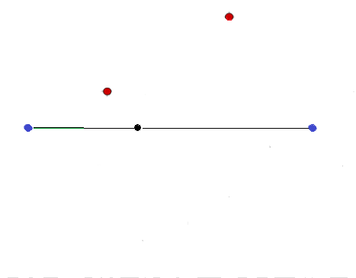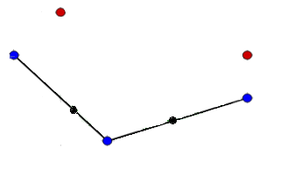

A

B

A

B