Shades of Gray(water)- Activity Setup
Materials
- shoebox | - 2 measuring cups marked in ml
- (optional) 8 Popsicle sticks (see note below) | - scissors
- (optional) duct tape | - box cutter
- 6 funnels | - marker
- tubing that fits on the bottom of the funnels | - masking tape
Instructions
- Use tape and Popsicle sticks to reinforce the shoebox sides. (A)
(optional; only needed for shoeboxes not made of sturdy cardboard)
- Use the box cutter to make six cut marks on the side of the shoebox that will be the top. (B)
- Label the inside of each funnel with the following descriptions: toilets, shower, clothes washer, baths, dishwasher, faucets. (C)
- Use masking tape and a marker to label the two measuring cups: graywater, blackwater. (D)
- Place the six funnels though the X cuts. (C and D)
- Cut tubing and place on the end of the funnels.
- Place tubes from shower, clothes washer, baths, dishwasher and faucets into the Graywater cup.
- Place the tube from the toilets funnel into the Blackwater cup.
C
- The final setup should look like image D, below.
A
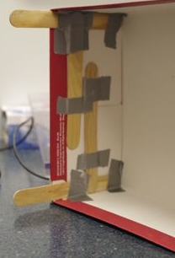
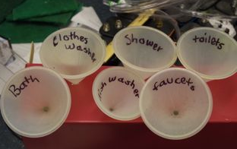

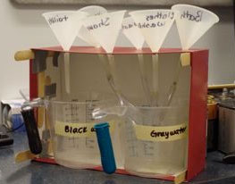
D
B
