World Oil Consumption Over Time Datasheet (Advanced)
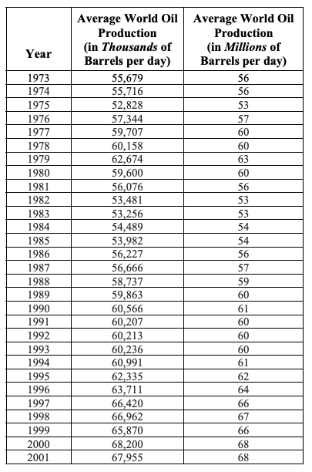

Source: Energy Information Administration, US Department of Energy,
http://www.eia.doe.gov/emeu/cabs/nonopec.html

