Saltwater Circuit Worksheet

Step 1: Prepare three saltwater mixtures. Label each mixture from lowest density (A), middle density (B), and greatest density (C). Fill in the corresponding density information in the table below.

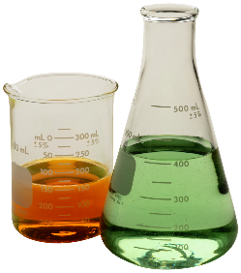
Table 1: Final Results
Label | Density
A
B
C

Step 2: Visual Ranking (Qualitative Method)
Using your saltwater circuit, rank the mixtures by how bright the light gets once you insert your electrodes into the water. Rank the three mixtures from lowest to highest and record your results. Fill in Table 2 with your results

Table 2: Visual Rankings
Low | Medium | High

