Example Case Study Worksheet 2
Several cook stove research projects are currently in progress. One project, called REACCTING, is described below. Read this study overview and answer the questions that follow.

Overview of REACCTING Study
REACCTING (Research on Emissions, Air quality, Climate, and Cooking Technologies in Northern Ghana) is an ongoing interdisciplinary randomized cook stove intervention study in the Kassena-Nankana District of Northern Ghana. The study tests two types of biomass burning stoves that have the potential to meet local cooking needs and represent different “rungs” in the cook stove technology ladder: a locally made low-tech rocket stove and the imported, highly efficient Philips gasifier stove. Diverse measurements assess different points along the causal chain linking the intervention to final outcomes of interest. We assess stove use and cooking behavior, cooking emissions, household air pollution and personal exposure, health burden and local-to-regional air quality.
Summary: This study compared two different improved stoves (low-cost, high-cost) to traditional cooking methods. Researchers collected air quality data, stove use/cooking behavior data, and health data in order to understand the impact of replacing traditional stoves with improved cook stoves.

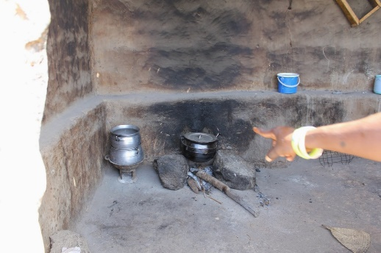
What was the team interested in?
- Cooking Behavior: Surveys collected information on household demographics, attitudes and priorities related to cooking, cooking behaviors (such as the number and type[s] of stoves used, type[s] of fuel used, types of food cooked, etc.), knowledge and perceptions of health and environmental issues related to cooking practices, demand for new stoves, and self-reported health symptoms. In a subset of homes, temperature sensors were added to the stoves to verify stove use data.
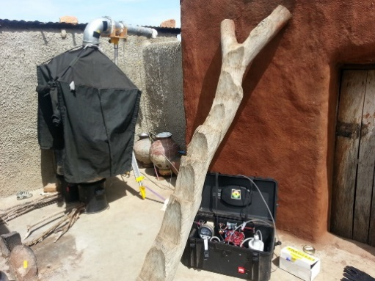
- Cooking Emissions: A portable emission monitoring system enabled the monitoring of particular stoves during cooking events. These systems collected real-time CO₂, CO, NO, NO₂, VOCs, and PM (particulate matter) data using a portable emission measurement system. The black hood (in the photograph to the right) traps all of the emissions and sends them to the monitoring device via the tubing. This data helps researchers understand how stove and fuel types affect emissions, enabling direct comparisons of cooking tools.
- Personal Exposure and Household Air Quality: To assess exposure of individuals in the household (primarily cooks and children), some individuals wore small, real-time CO monitors around their necks (in the “breathing zone”) and personal PM samplers for periods of 48 hours. During these tests, stationary air quality monitors also collected data on CO, CO₂ and PM data in the cooking areas of the homes. In addition to measuring emissions, it is important to determine how the emissions are impacting people and what their exposure to those emissions looks like. The photo on the next page shows a boy wearing a CO monitor in his shirt pocket.

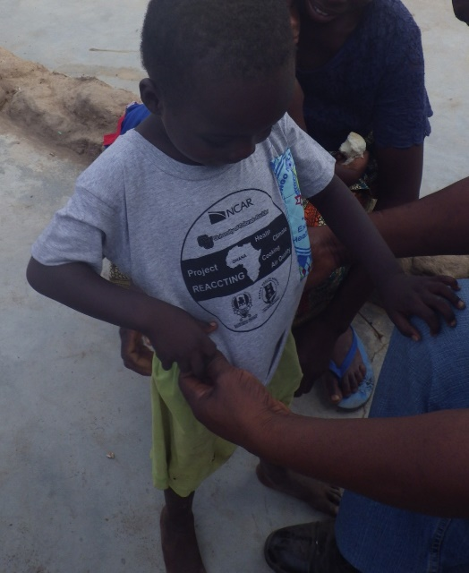
- Health Burden: In addition to self-reported health symptoms and conditions, health measurements were taken twice a year that included anthropometrics (height, weight and mid-upper arm circumference) and bloodspots (analyzed for biomarkers that indicate systemic inflaming or vascular injury).
- Regional Air Quality: The G-Pods (similar to Pods) configured to measure O₃, CO, NO, NO₂, CO₂, and VOCs, as well as wind speed and direction, were placed throughout the study region to measure ambient, outdoor air quality. Several other higher-cost, higher-quality instruments measured the same compounds as well as a PM monitoring system at the study’s core monitoring site. These measurements are necessary to understand the background air quality in Ghana.
Procedure—What did the researchers do?
(What) For which pollutants will you collect data?
Researchers collected CO, NO, NO₂, CO₂, O₃, VOCs, and PM (particulate matter) data as well as other measurements such as ambient temperature and stove temperature.
(Where) Describe where you will place your monitors?
Researchers placed air quality monitors in the homes and in the community to understand air quality indoors and outdoors. They collected data in the “breathing zone” of participants to understand exposure, and they captured and analyzed stove emissions using hoods like in the second photograph above.
(Who) Are you most interested in the exposure of any specific individuals or family members?
Researchers were most interested in the exposure of women and children since they do most of the cooking and spend much of their time inside the homes.
List one other piece of data that would be helpful to have.
Researchers collected survey data to understand how people liked the stoves and whether they would be willing to pay for an improved stove. Researchers also collected health data to look for changes and improvements that may be related to using a different type of stove.
Questions—Answer on a separate piece of paper.
- List two similarities between your study design and the REACCTING cook stove project.
- List two differences between your study design and the REACCTING cook stove project.
- What is one change you would make to your study design after reading about this example?
///
Source of text and information on Worksheets 1 and 2:
Dickinson, K.L., E. Kanyomse, R. Piedrahita, E. Coffey, I.J. Rivera, J. Adoctor, R. Alirigia, D. Muvandimwe, M. Dove, V. Dukic, M.H. Hayden, D. Diaz-Sanchez, A. Abisiba, D. Anaseba, Y. Hagar, N. Masson, A. Monaghan, A. Titiati, D.F. Steinhoff, Y.-Y. Hsu, R. Kaspar, B. Brooks, A. Hodgson, M. Hannigan, A. Oduro, C. Wiedinmyer: Research on Emissions, Air quality, Climate, and Cooking Technologies in Northern Ghana (REACCTING): Study Rationale and Protocol, BMC Public Health, 2015, 15:126, doi:10.1186/s12889-015-1414-1. http://www.biomedcentral.com/1471-2458/15/126
Source of all photos on Worksheets 1 and 2: http://www.reaccting.com/

