Pre-Activity Worksheet

Section 1: Statistics Review: Summarizing Data
Sample # | Data Set A | Data Set B
1 | 5 | 2
2 | 4 | 3
3 | 7 | 2
4 | 5 | 14
5 | 4 | 1
Data Distribution
Circle the correct answer:
Which data set has a higher mean? A B

Which data set has a higher median? A B

Which data set has a larger range? A B

If you were to collect more samples and the mean and median for the above data
remained the same, which data set would you expect to be normally distributed? A B
(Hint: In a normal distribution, mean = median. In a skewed distribution, mean ≠ median.)

Standard Deviation and Outliers
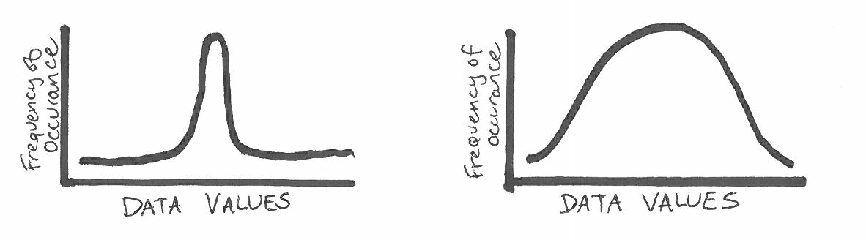

Circle the figure that has the higher standard deviation.

In the chart above, circle any points you suspect to be outliers.

Section 2: Visualizing Data, Graphing
Imagine you have collected air quality data inside your home, and now you want to analyze the data from one 24-hour period. Focus on the pollutant—carbon dioxide (CO₂). What type of plot would you choose?
Next, make a sketch of what you might expect this plot to look like. Feel free to annotate your plot with activities such as sleeping, left home, returned home, etc. (Hint: Consider where CO₂ comes from, and how these “sources” might change throughout the day.)
Plot type:
Plot sketch:

Section 3: Comparing Data Sets
Take a look at the plot below of hypothetical data on car ages and their prices. Do you see a relationship in the data? Does this make sense? Why or why not? Estimate the R-squared for this data set. (Remember R² is explained in the Pre-Activity Reading as a value between 0 and 1.)

Bonus Activity
Google “air quality infographic” and click on the image results. Skim through these and find one that interests you. Be prepared to share a one-sentence summary of the infographic and why you liked it.

