Current Event Article Example Answer
Characterizing and understanding vehicle emissions is important to minimize air pollution, improving public health and reducing impacts to the global climate. The article below discusses an air quality issue in Paris, France, and demonstrates how air quality can affect daily routines.
Note that the pollutant mentioned in the article is “PM,” or particulate matter. Using the air quality monitoring Pods in class, we will be studying gas-phase pollutants. Do you remember the difference between the two? Both types of air pollution are important and relevant to monitoring vehicle emissions.
Answer the following questions in a paragraph:
- Why would French government officials chose to target vehicles to lower emissions?
- Are there other sources they could have chosen instead?
- As a citizen, how would you react?
Paris Car Ban Imposed after Pollution Hits High
Hugh Schofield, BBC News
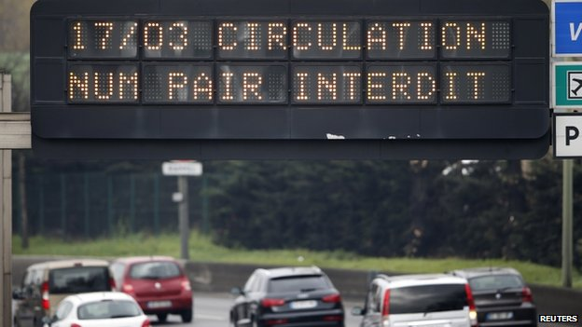
Hugh Schofield in Paris: “At the end of last week it was bad—you really felt it catch in your throat.”
Drivers on Monday were confronted by signs warning them that those with even-numbered license plates were not allowed on the roads.
Hundreds of police monitored traffic in Paris on Monday after high pollution levels prompted the French government to impose major restrictions.
Only motorists with odd-numbered number plates were allowed to drive. Those with even-numbered plates will be allowed to travel on Tuesday after the success of Monday's initiative led to a fall in pollution. Ministers acted after air pollution exceeded safe levels for five days running in Paris and surrounding areas. But the environment ministry said lower traffic levels during throughout Monday and a change in weather conditions had significantly improved the smog that has descended on Paris over the past week. The smoggy conditions have been caused by a combination of cold nights and warm days, which have prevented pollution from dispersing.
It is not hard to spot even-numbered registration plates on the streets of Paris. Plenty of people seem to have decided to chance it. Either they reckoned their journey was too important to cancel, or the risk of a 22-euro (£18) fine was not enough to concern them.
But overall, it seems Parisians are playing the game. Most cars on the roads are indeed odd-plated, and traffic seems lighter than usual. Fewer vehicles means fewer particles, so presumably the measure is having an effect.
It is hard to criticize a measure whose aim is to protect people's health. But there are legitimate questions over the timing of the alternate driving scheme. Pollution levels peaked at the end of last week, and were already falling. So why now?
Could the Paris mayoral elections next weekend possibly have anything to do with it? Surely not.
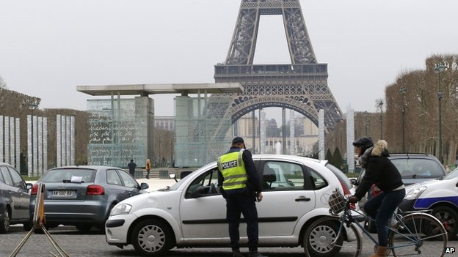
The measure has been tried once before, in 1997. Paris air quality monitoring body Airparif says it had a noticeable impact on improving air quality, although critics have disputed its findings.
Pollution offending drivers received fines and in some cases has their vehicles impounded.

Motorcycles were also covered by the ban, which ran from 5:30 am to midnight. There were exceptions for taxis, commercial electric and hybrid vehicles and for cars carrying three or more passengers. Those flouting the restrictions faced a small fine. There was free parking for those with number-plates ending in an even number. About 700 police ran nearly 180 control points around the Paris region, correspondents say, handing out tickets to offenders. Police were reported to have ticketed nearly 4,000 people by midday on Monday, and 27 drivers had their cars impounded for refusing to co-operate with officers. Delivery companies are already complaining of lost income, BBC Paris correspondent Hugh Schofield says. Politically the stakes are high, with elections for Paris mayor due to start next week.
Opposition leader Jean-Francois Cope complained that the ban lacked “coherence, explanation and on the ground it’s really panic.” On Friday, public transport was made free of charge for three days in an attempt to encourage people to leave their cars at home. This measure continued on Monday. The capital’s air quality has been one of the worst on record, French environmental agencies say, rivalling the Chinese capital, Beijing, one of the world's most polluted cities. On Friday, pollution levels hit 180 microgrammes of PM10 particulates per cubic meter, more than double the safe limit of 80. PM10 particulates are emitted by vehicles, heating systems and heavy industry. Officials say one heavy rainfall would have more effect than a one-day ban.
Source: Hugh Schofield, “Paris Car Ban Imposed after Pollution Hits High.” March 18, 2014. BBC News Europe (online); http://www.bbc.com/news/world-europe-26599010
Possible responses to questions:
- Why would French government officials choose to target vehicles to lower emissions?
- Are there other sources they could have chosen instead?
Example answer: Regulators could have chosen other emitters, such as industry, electricity generation, or even agriculture. They may have chosen to target vehicles because either it was too difficult to impose further regulations on industry or the industry and electricity generation sectors in France are already well-regulated. Additionally, by limiting the cars on the road, they have the potential to make an immediate impact. If you wanted to regulate a power plant, 1) it would be difficult to simply shut it down for a few days (because people rely on that energy) and 2) adding more control devices takes time and money. Banning half of the cars from the road is a quick and fairly simple measure. Although, I imagine it would be more difficult to implement a plan like this in the U.S. given the politics here.

