All About Waves—Notes Outline
A ______________ is a disturbance that carries ______________ from one place to another.
___________ is NOT carried with the wave! A wave can move through matter (a ___________). If it must have a medium, it is called ______________ wave. If it can travel without a medium (such as in space), it is called ______________ wave.
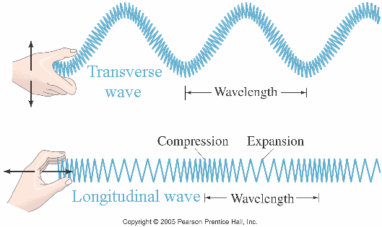
Wave Types
- __________ waves: Waves in which the medium moves at __________ angles to the wave direction.
Parts of a transverse wave:
__________: the highest point of the wave
trough: the __________ point of the wave
- _______________ (longitudinal) wave: Waves in which the medium moves ____________________________ in the same direction as the wave.
Parts of a compressional wave:
____________: where the particles are close together
Comparing transverse and longitudinal waves.
____________: where the particles are spread apart
Wave properties depend on what ________________________ makes the wave.
- __________: The distance between one point on a wave and the ________________________________ on the next wave.
- __________: How many waves go past a point in __________; measured in __________ (Hz). The higher the frequency, the more __________ in the wave.
- __________: How far the medium (crests and troughs, or compressions and rarefactions) moves from _______________________ (the place the medium is when not moving). The __________ energy a wave carries, the __________ its amplitude. Amplitude is related to energy by ____________.
- __________: Depends on the medium the wave is traveling in. This varies in __________, __________ and __________.
Equation for calculating wave speed:
wave speed = __________ (in m) x __________ (in Hz)
Problem: So- if a wave has a wave speed of 1000 m/s and a frequency of 500 Hz, what is its wave length? Answer: wavelength= _________________________
Changing Wave Direction

__________: When waves __________ off a surface. If the surface is __________, the angle at which the wave hits the surface will be the __________ as the angle that the wave __________ the surface. In other words, the angle _____ equals the angle _____. This is called the ___________________________________________.

__________: Waves can __________; this happens when a wave enters a __________ and its __________; the amount of bending depends on the medium it is entering

__________: The bending of waves __________ an object. The amount of bending depends on the ______________ and the ______________.
A demonstration of refraction.

__________ obstacle, __________ wavelength = low diffraction

__________ obstacle, __________ wavelength = large diffraction

